True Homonyms

🔹 What Are True Homonyms
# Source: AI Source: Provided by: [Data Path: Persons Table -> ID Column: 1, Name_En Column: Motasem Essam] -> From: [Chatgpt (GPT-4-turbo)] on [8/1/2025]
True homonyms are words that are spelled the same and pronounced the same, but have completely different and unrelated meanings.
They are sometimes simply called “homonyms” in casual use, but linguists call them true homonyms to distinguish them from homophones and homographs.

🧱 Key Features of True Homonyms
# Source: AI Source: Provided by: [Data Path: Persons Table -> ID Column: 1, Name_En Column: Motasem Essam] -> From: [Chatgpt (GPT-4-turbo)] on [8/1/2025]
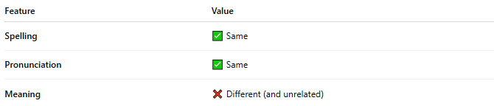
Feature | Value
Spelling | ✅ Same
Pronunciation | ✅ Same
Meaning | ❌ Different (and unrelated)

📝 Examples of True Homonyms
# Source: AI Source: Provided by: [Data Path: Persons Table -> ID Column: 1, Name_En Column: Motasem Essam] -> From: [Chatgpt (GPT-4-turbo)] on [8/1/2025]
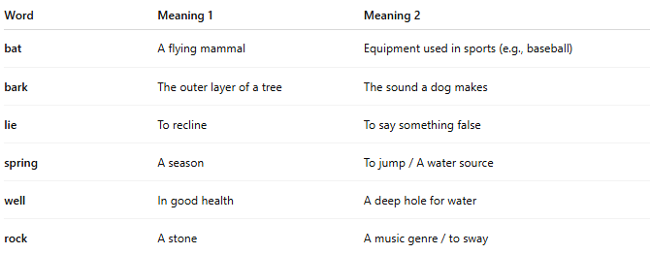
Word | Meaning 1 | Meaning 2
bat | A flying mammal | Equipment used in sports (e.g., baseball)
bark | The outer layer of a tree | The sound a dog makes
lie | To recline | To say something false
spring | A season | To jump / A water source
well | In good health | A deep hole for water
rock | A stone | A music genre / to sway

🧠 Why Are True Homonyms Important?
# Source: AI Source: Provided by: [Data Path: Persons Table -> ID Column: 1, Name_En Column: Motasem Essam] -> From: [Chatgpt (GPT-4-turbo)] on [8/1/2025]
- They show how context determines meaning in English.
- Common in puns, riddles, and poetic ambiguity.
- Useful for understanding semantic flexibility in language.

🎨 Examples in Sentences
# Source: AI Source: Provided by: [Data Path: Persons Table -> ID Column: 1, Name_En Column: Motasem Essam] -> From: [Chatgpt (GPT-4-turbo)] on [8/1/2025]
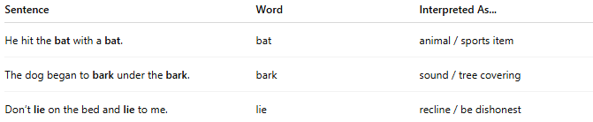
Sentence | Word | Interpreted As...
He hit the bat with a bat. | bat | animal / sports item
The dog began to bark under the bark. | bark | sound / tree covering
Don’t lie on the bed and lie to me. | lie | recline / be dishonest

🧭 Comparison with Other Homonym Types
# Source: AI Source: Provided by: [Data Path: Persons Table -> ID Column: 1, Name_En Column: Motasem Essam] -> From: [Chatgpt (GPT-4-turbo)] on [8/1/2025]
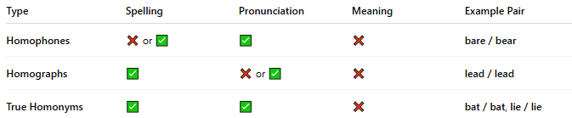
Type | Spelling | Pronunciation | Meaning | Example Pair
Homophones | ❌ or ✅ | ✅ | ❌ | bare / bear
Homographs | ✅ | ❌ or ✅ | ❌ | lead / lead
True Homonyms | ✅ | ✅ | ❌ | bat / bat, lie / lie

